***5/3/25 Author Component Creation***

***DAY 3***

*Assignment*

1)Create an Author component which will have 3 fields

Author Name-single line text field-Mandetry

Author Bio-multiline text field-Mandetry

Dob-date picker-Mandetry

create the component with above dialog fields

Fetch these value directly using htl properties tag

2)What is Dialog validation how to use them?

3)What is client lib?

4)Implement client lib make authorName h1

Make author bio normal body text

Bold the dob

5)What is extraclientlib and how to create custom ?

**1)CREATING AUTHOR COMPONENT**

***AEM----TOOLS----CRXDE Lite***

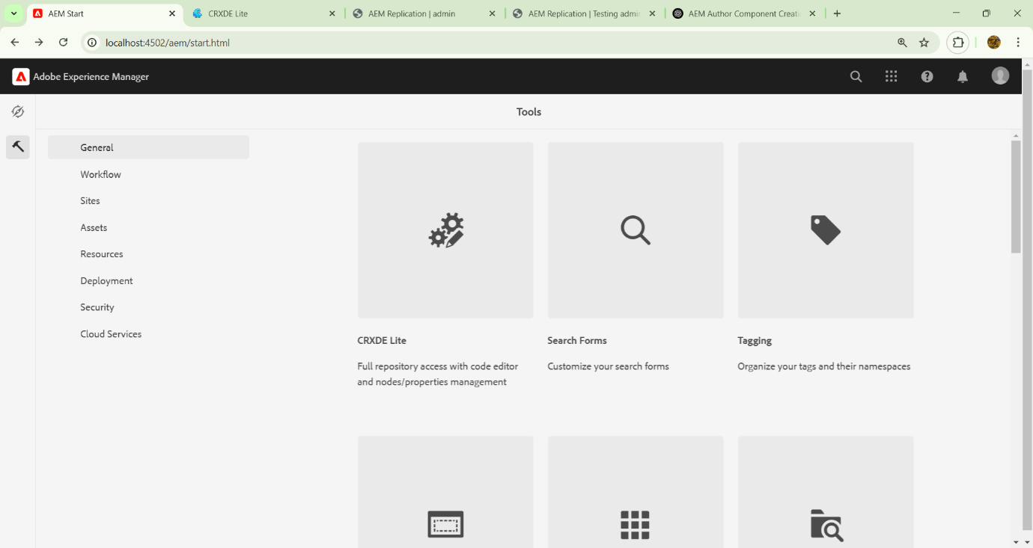

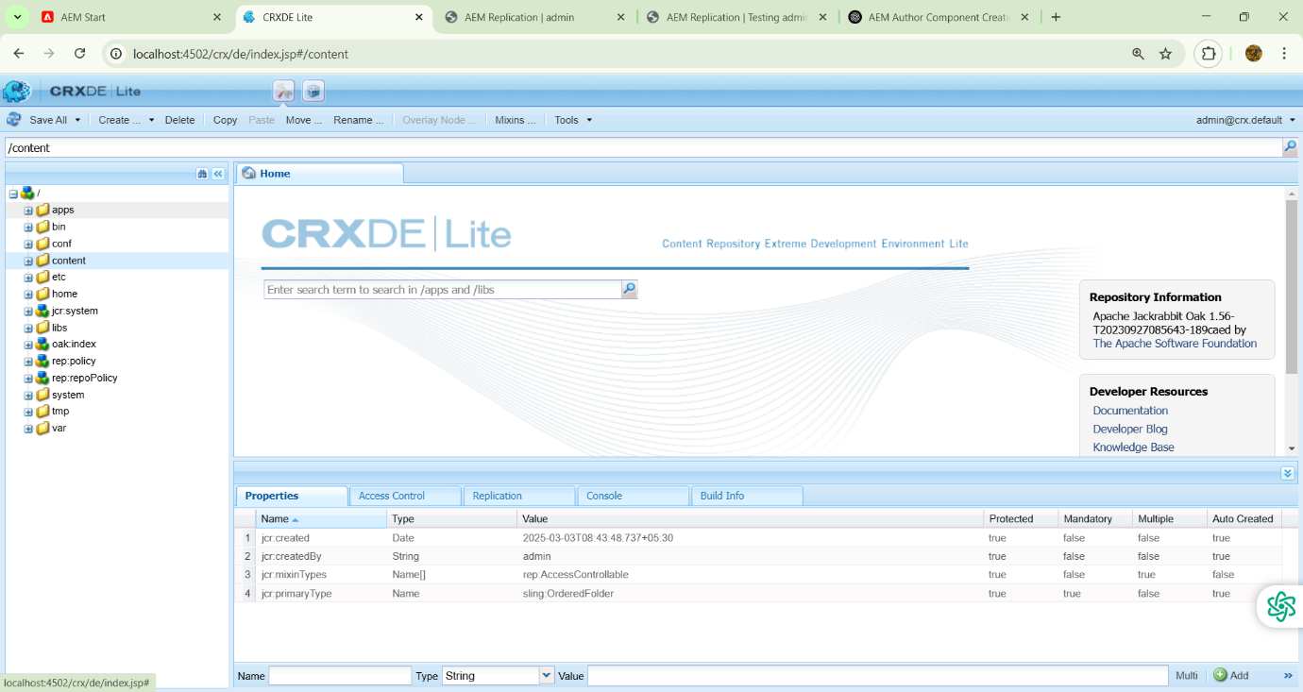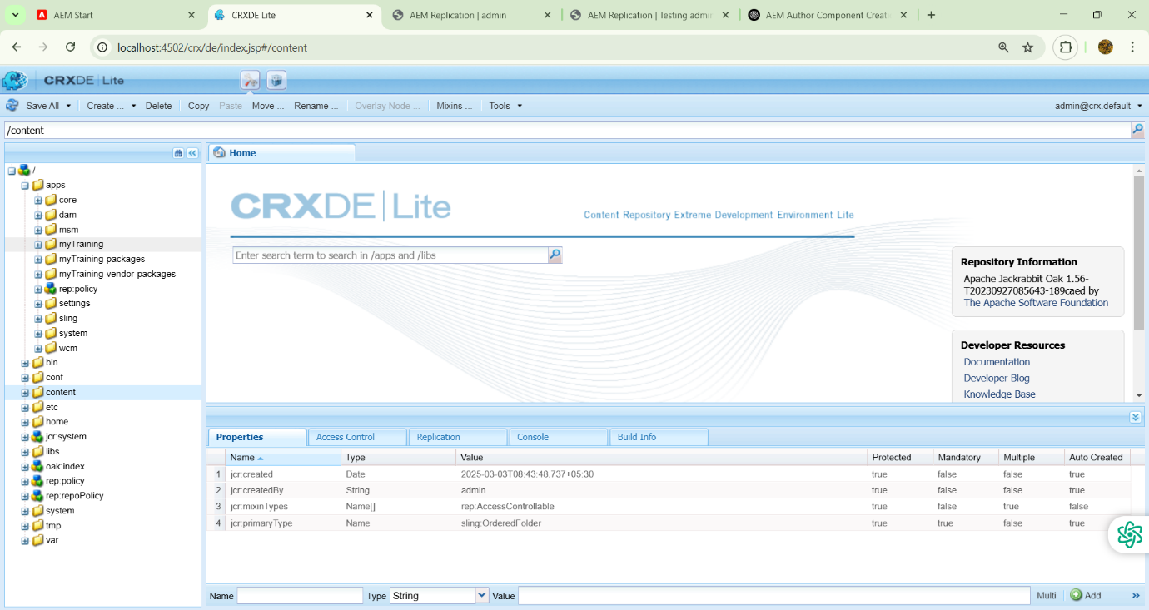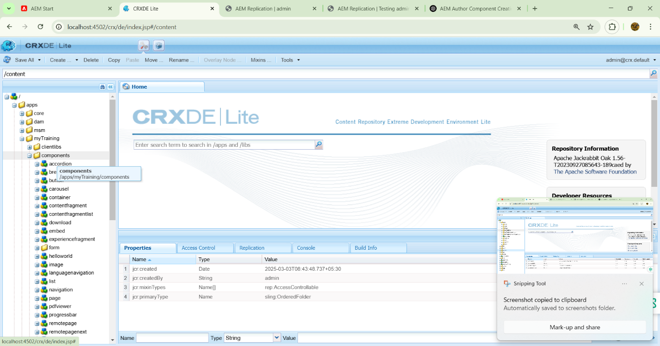

***Expand apps—myTraining folder—components***

***Create a node***

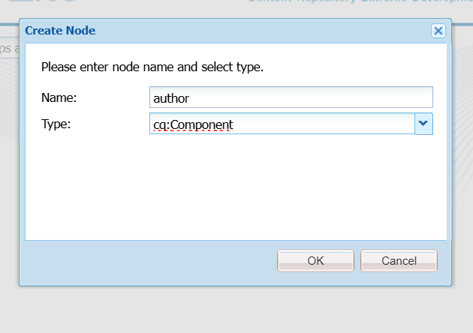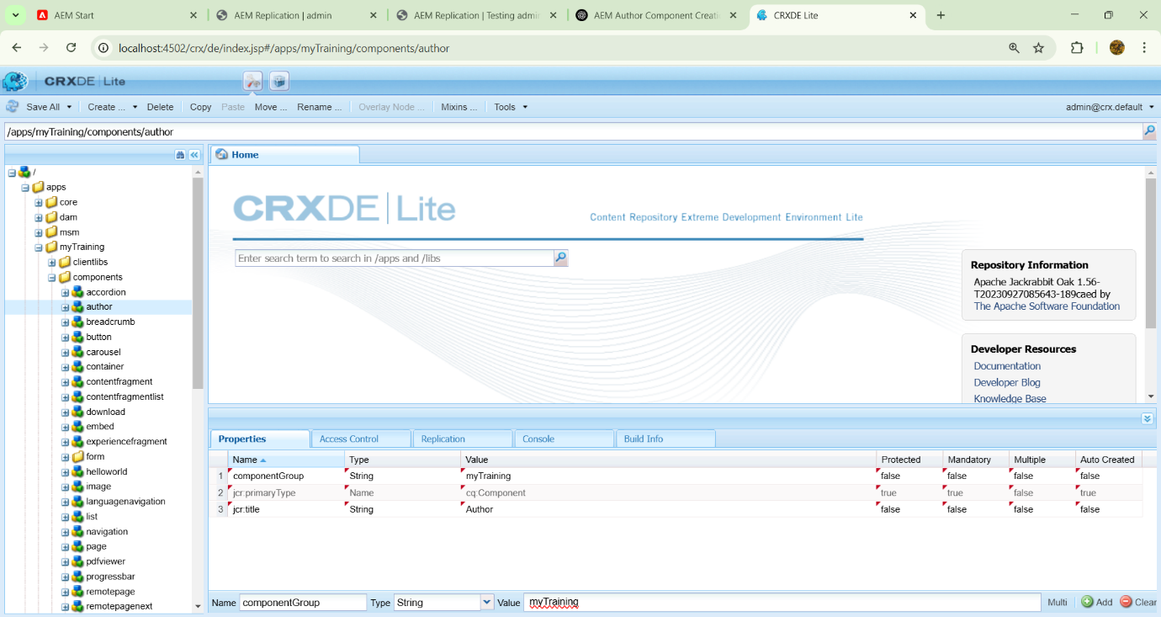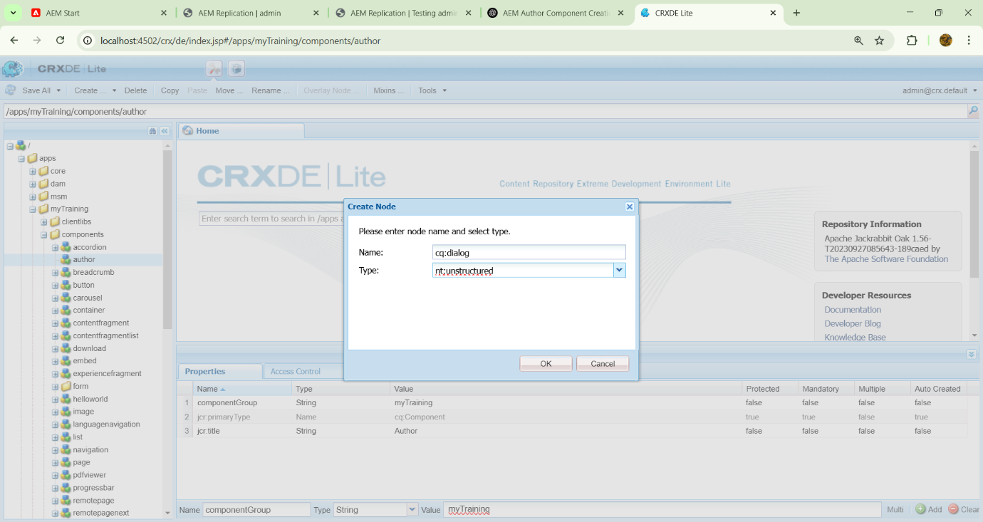

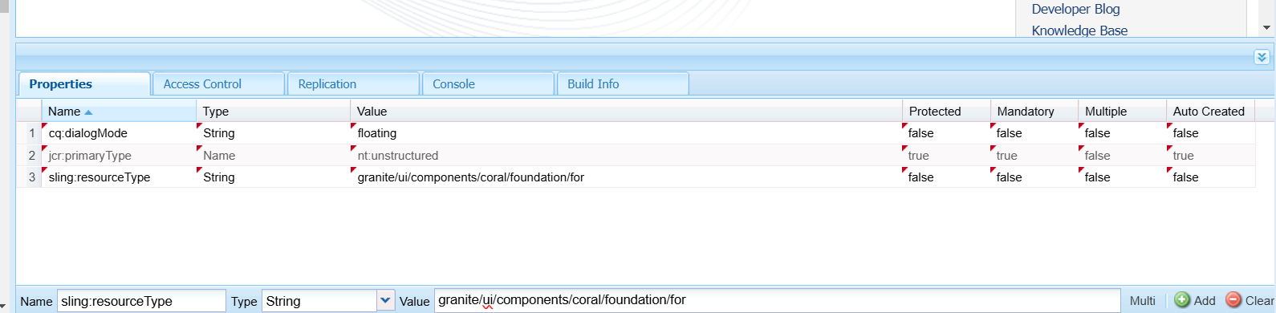

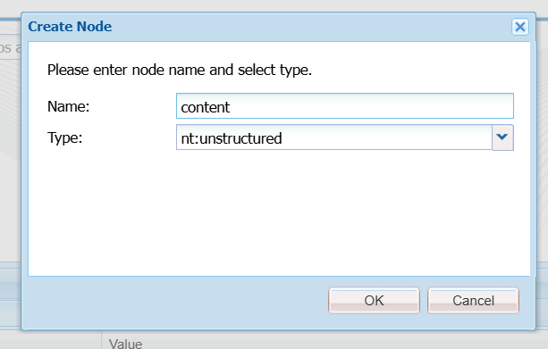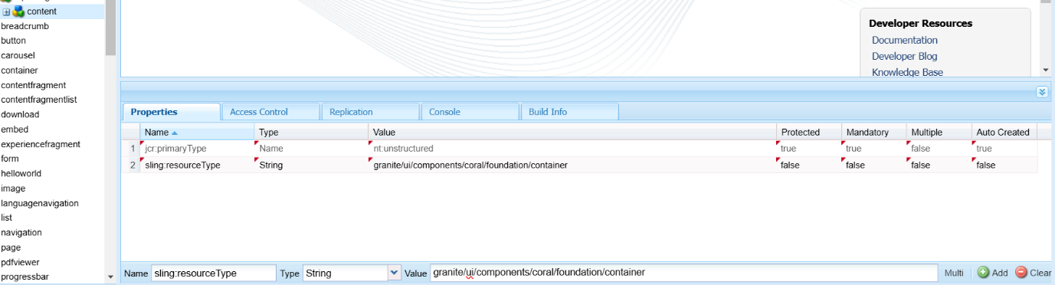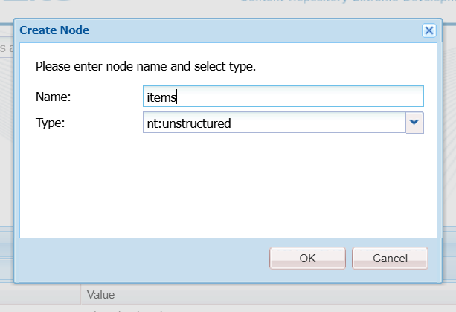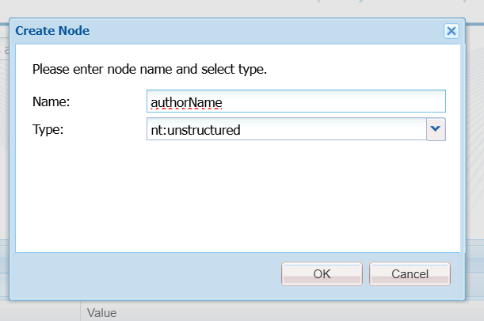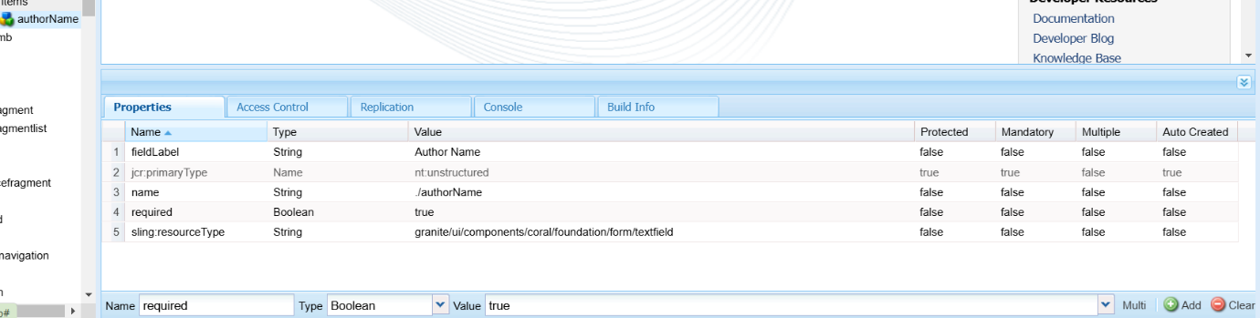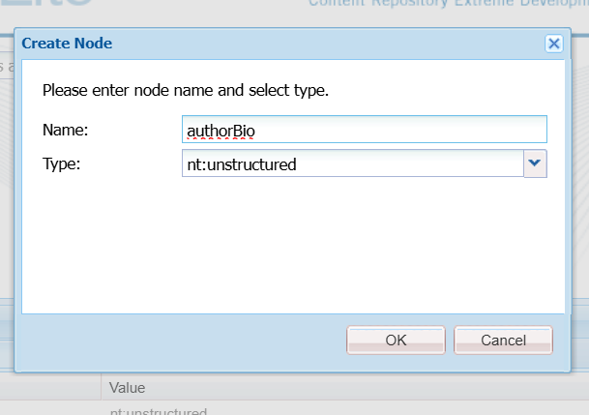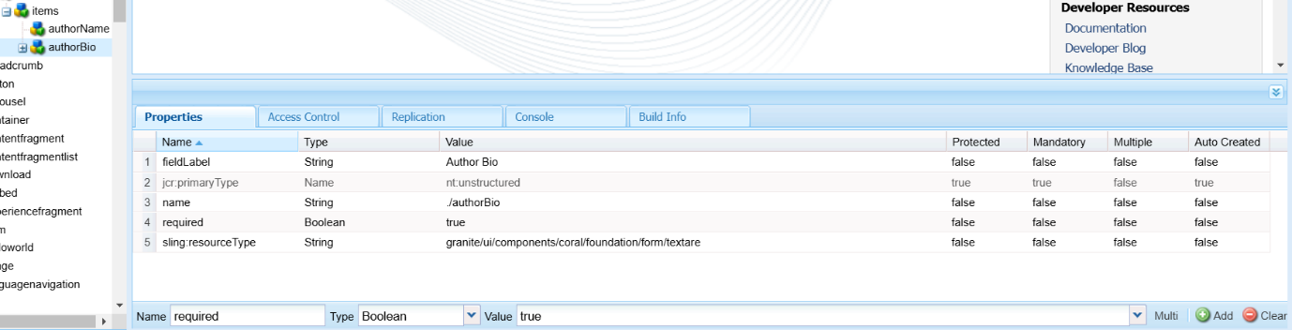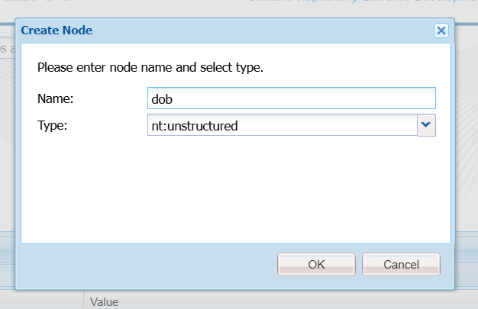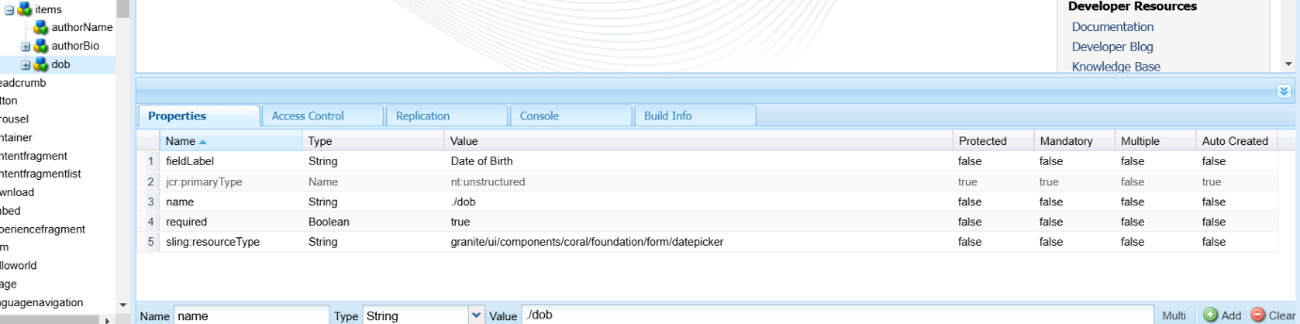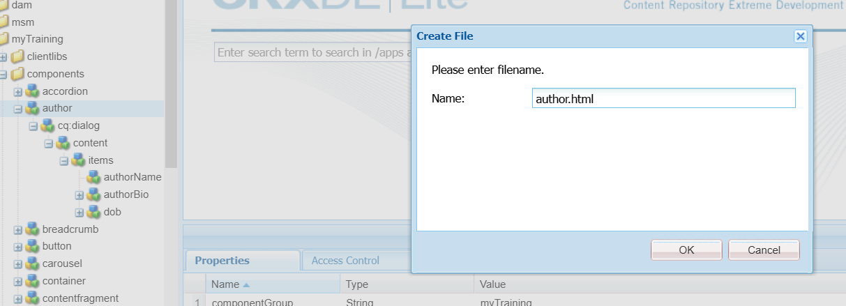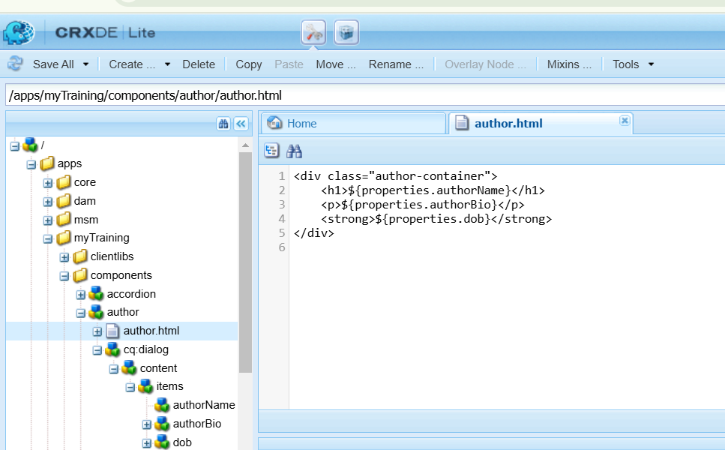

**2)What is Dialog validation how to use them?**

Dialog validation in Adobe Experience Manager (AEM) ensures that users enter valid input when configuring components. This helps maintain data integrity and improves authoring experience.

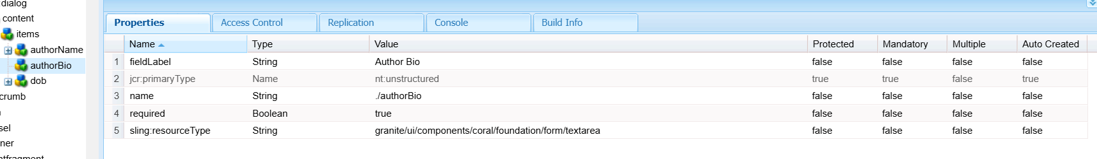

**3)What is client lib?**

A Client Library (clientlib) in AEM is a way to manage and include CSS, JavaScript, and frontend assets efficiently. It helps optimize performance by bundling and minifying resources.

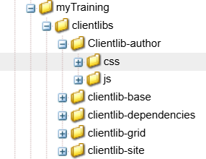

**4)Implement client lib make authorName h1**

**Make author bio normal body text**

**Bold the dob**

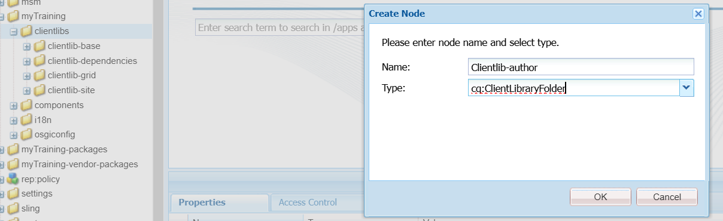

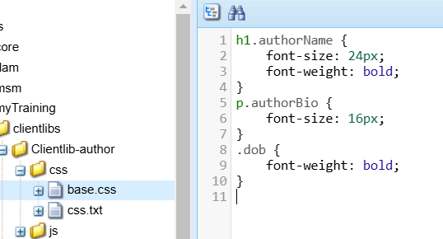

**5)What is extraclientlib and how to create custom ?**

extraClientLibs allows you to include additional client libraries in a component, even if they are not part of the component’s default category.

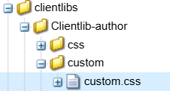

**IYSHWARYA K**